Contact Form – Digital Doorways

Open Theatre and Active Arts would like to know your contact information.​ | 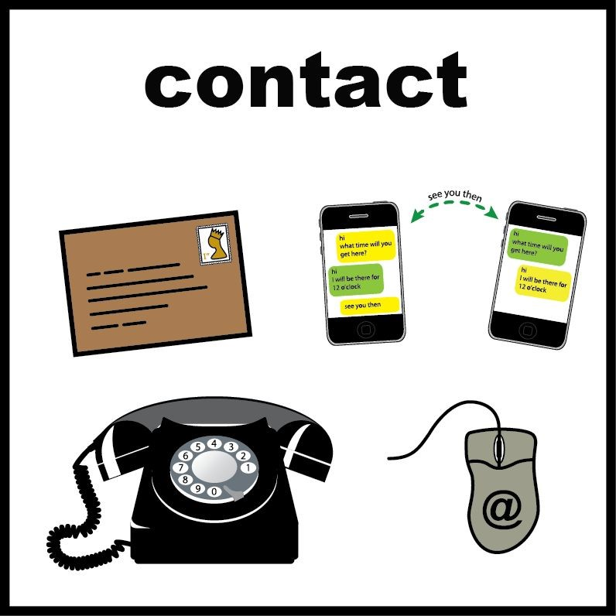
This information will only be used to contact you about Open Theatre and Active Arts ​activities. | 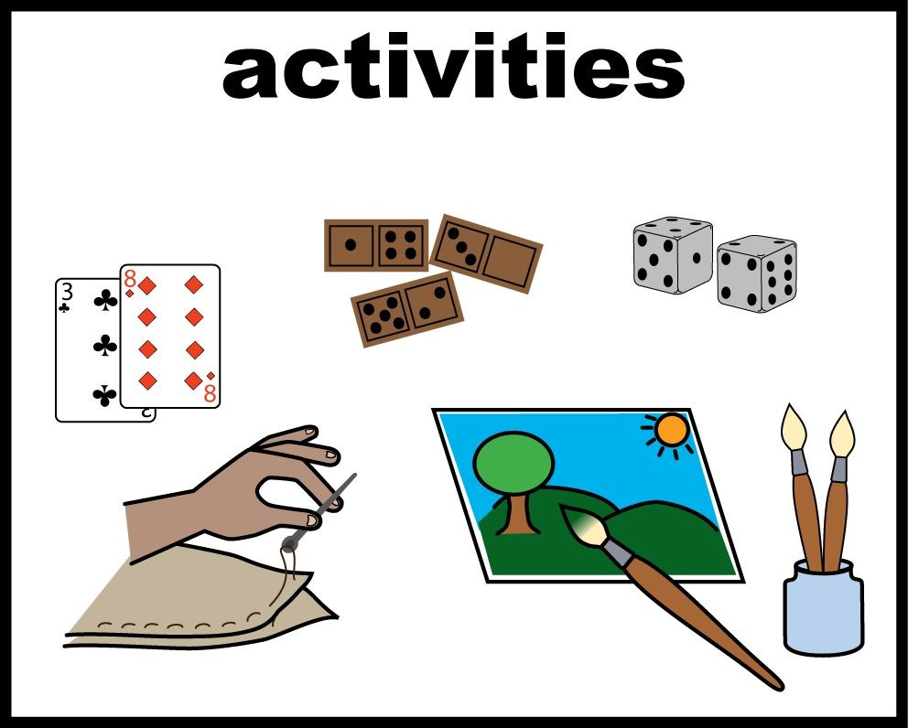
It may also be used to contact people if there was an ​emergency.​ | 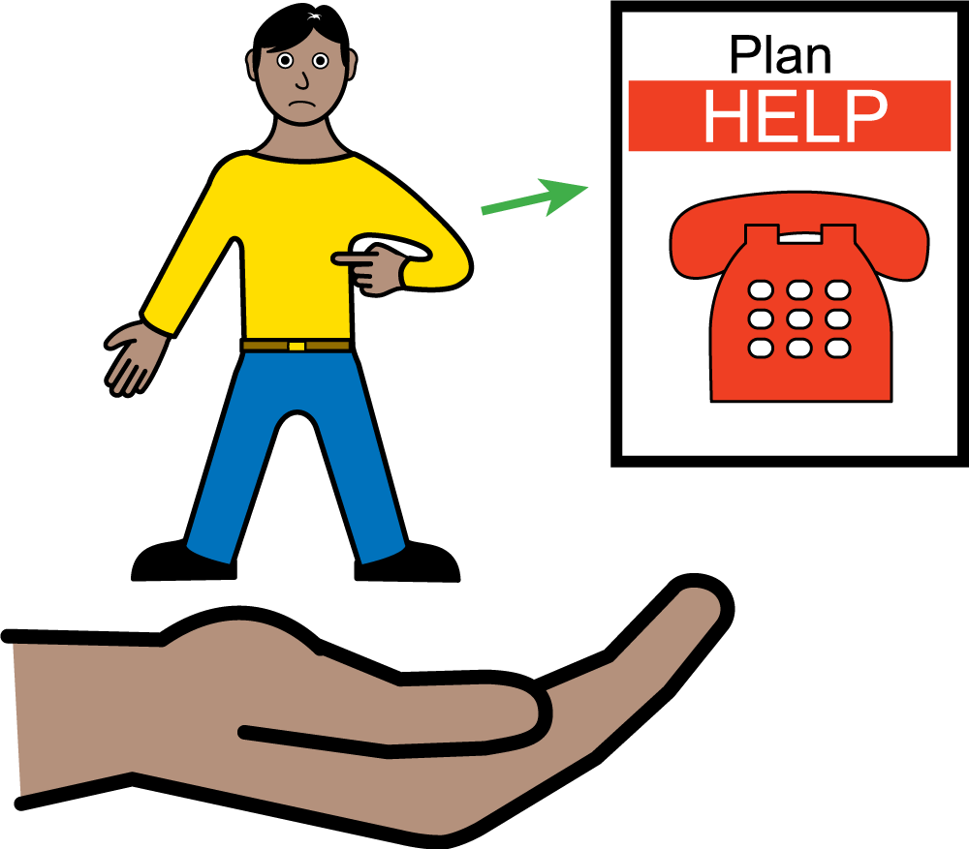
This ​information will be kept safe and only accessed by Open Theatre and Active Arts staff. | 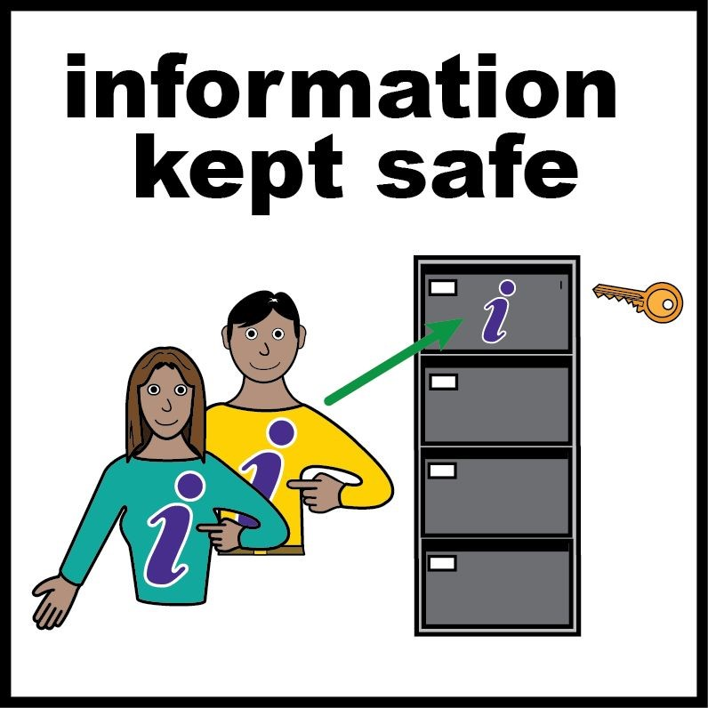

Name
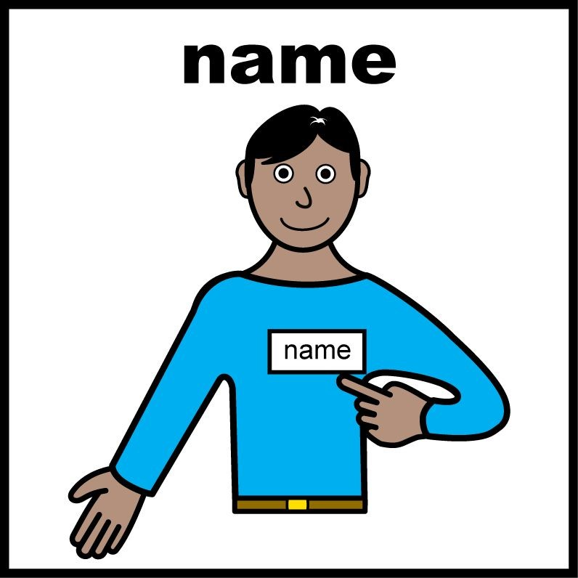
Date of birth
Ethnicity
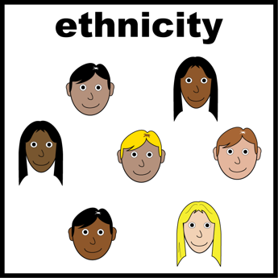
Address
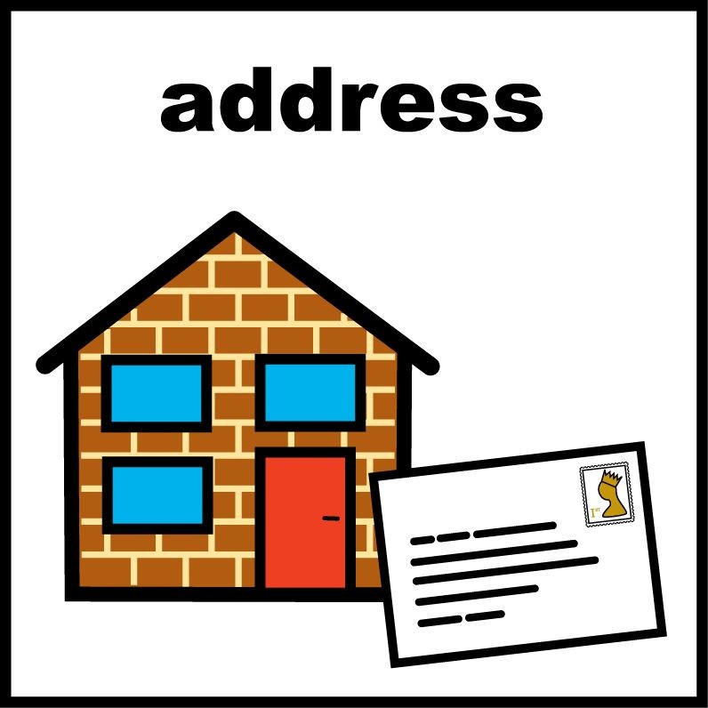
Email Address
Telephone Number
Parent/Carer Name
Parent/Carer Email
Address
Parent/Guardian
Telephone Number
Medical Details/
Allergies that we should be aware of
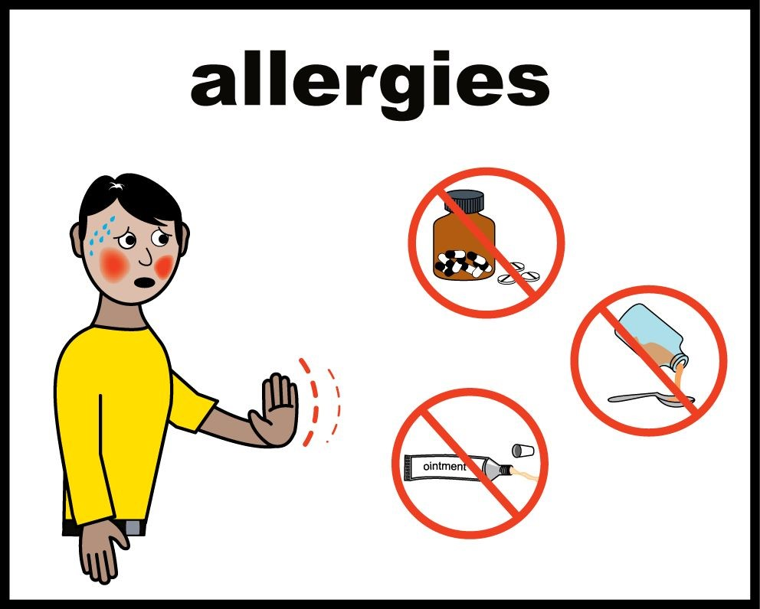
Disabilities you have
School You Attend

